**Problem Statement (Bank Loan)**

Report page 1(SUMMARY)

Key Performance Indicators (KPIs) Requirements:

1.Total Loan Applications: We need to calculate the total number of loan applications received during a specified period. Additionally, it is essential to monitor the Month-to-Date (MTD) Loan Applications and track changes Month-over-Month (MoM).

2.Total Funded Amount: Understanding the total amount of funds disbursed as loans is crucial. We also want to keep an eye on the MTD Total Funded Amount and analyse the Month-over-Month (MoM) changes in this metric.

3.Total Amount Received: Tracking the total amount received from borrowers is essential for assessing the bank's cash flow and loan repayment. We should analyse the Month-to-Date (MTD) Total Amount Received and observe the Month-over-Month (MoM) changes.

4.Average Interest Rate: Calculating the average interest rate across all loans, MTD, and monitoring the Month-over-Month (MoM) variations in interest rates will provide insights into our lending portfolio's overall cost.

5.Average Debt-to-Income Ratio (DTI): Evaluating the average DTI for our borrowers helps us gauge their financial health. We need to compute the average DTI for all loans, MTD, and track Month-over-Month (MoM) fluctuations.

6.Good Loan v Bad Loan KPI’s

1. Good Loan:

Good Loan Application Percentage

Good Loan Applications

Good Loan Funded Amount

Good Loan Total Received Amount

1. Bad Loan

Bad Loan Application Percentage

Bad Loan Applications

Bad Loan Funded Amount

Bad Loan Total Received Amount

7.Loan Status Grid View

In order to gain a comprehensive overview of our lending operations and monitor the performance of loans, we aim to create a grid view report categorized by 'Loan Status.’ By providing insights into metrics such as 'Total Loan Applications,' 'Total Funded Amount,' 'Total Amount Received,' 'Month-to-Date (MTD) Funded Amount,' 'MTD Amount Received,' 'Average Interest Rate,' and 'Average Debt-to-Income Ratio (DTI),' this grid view will empower us to make data-driven decisions and assess the health of our loan portfolio.

Report Page 2 (OVERVIEW)

CHARTS

1.Monthly Trends by Issue Date (Line Chart): To identify seasonality and long-term trends in lending activities

2.Regional Analysis by State (Filled Map): To identify regions with significant lending activity and assess regional disparities

3.Loan Term Analysis (Donut Chart): To allow the client to understand the distribution of loans across various term lengths.

4.Employee Length Analysis (Bar Chart): How lending metrics are distributed among borrowers with different employment lengths, helping us assess the impact of employment history on loan applications.

5.Loan Purpose Breakdown (Bar Chart): Will provide a visual breakdown of loan metrics based on the stated purposes of loans, aiding in the understanding of the primary reasons borrowers seek financing.

6.Home Ownership Analysis (Tree Map): For a hierarchical view of how home ownership impacts loan applications and disbursements.

Metrics to be shown: 'Total Loan Applications,' 'Total Funded Amount,' and 'Total Amount Received’

Create a parameter for select measure to add this three section

Report Page 3 (Details)

1.GRID

Need for a comprehensive 'Details Dashboard' that provides a consolidated view of all the essential information within our loan data. This Details Dashboard aims to offer a holistic snapshot of key loan-related metrics and data points, enabling users to access critical information efficiently.

# Hardware & Software Requirements:

Hardware Requirements:

System (Small-scale Analysis, Personal Use)

1. **Processor:** Intel i5 (10th Gen or later) / AMD Ryzen 5 or higher

2. **RAM:** 8GB (minimum), 16GB (recommended for better performance)

3. **Storage:** 256GB SSD (minimum), 512GB SSD or higher (recommended)

4. **GPU:** Integrated graphics (sufficient for basic analytics)

5. **Internet:** Required for cloud-based tools and APIs

Software Requirements:

1.Operating System: Windows 10/11, macOS, or Linux

2. Programming Languages:

1. **Python** (Primary language for data analysis & ML models)

2. **R** (If using statistical analysis)

3. **SQL** (For database querying)

3. Development Tools: Jupyter Notebook / VS Code, SQL server management, **Git & GitHub**

4. Libraries for Data Analysis & Machine Learning:

1. **Pandas, NumPy** (Data processing)

2. **Matplotlib, Seaborn, Plotly** (Visualization)

3. **Scikit-Learn, XGBoost, TensorFlow** (ML modeling)

5. Data Visualization & Reporting; Power BI / Tableau (For dashboards and reports), Excel

# DATA CLEANING or PREPROSESING and EDA (Exploratory Data Analysis):

1.LOAD THE CSV FILE:

import pandas as pd

df = pd.read_csv("D:\power bi project\PROJECT\Bank Loan\Bank Loan dataset.csv")

df.head()

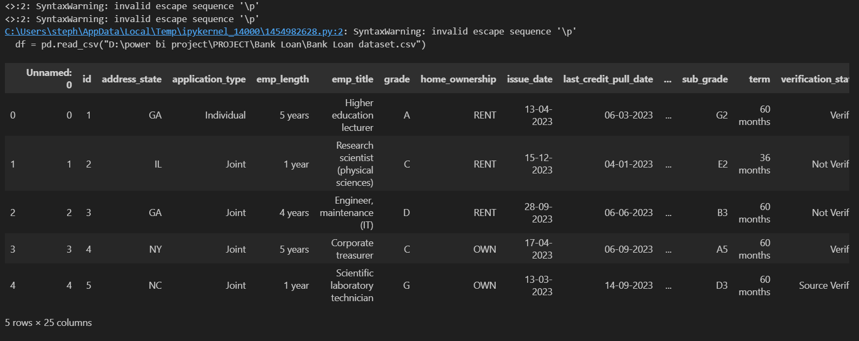

2. Check data types and missing values

print(df.info())

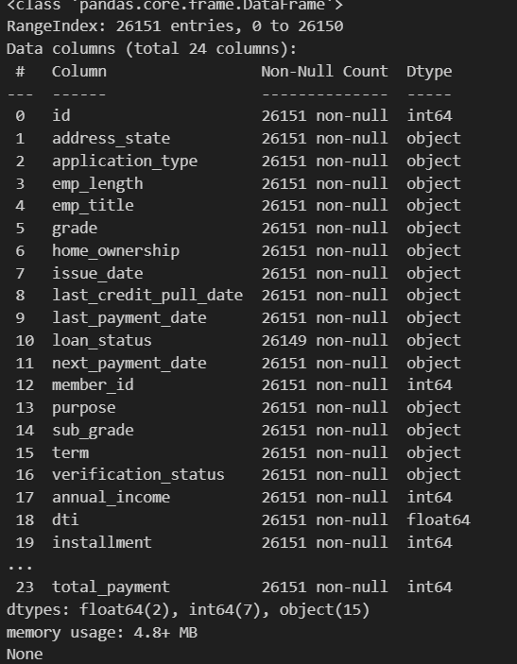

3. Summary statistics for numerical columns

print(df.describe())

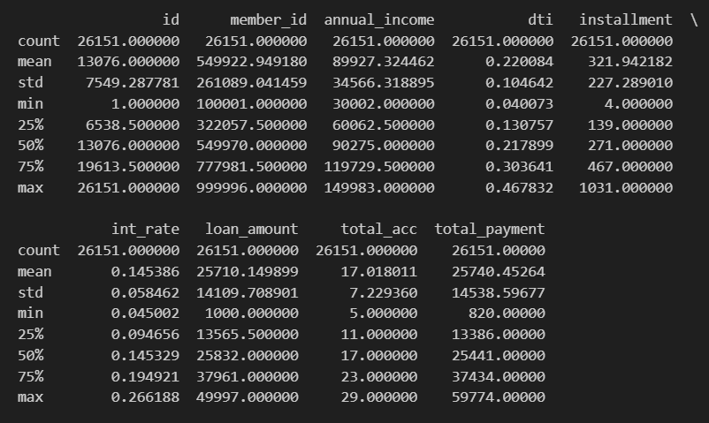

4.Check unique values in categorical columns

print(df.nunique())

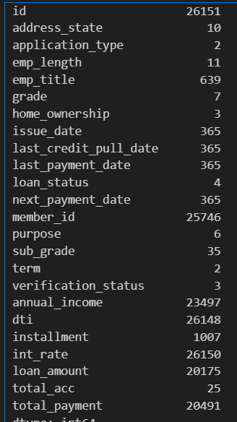

5.Count duplicates

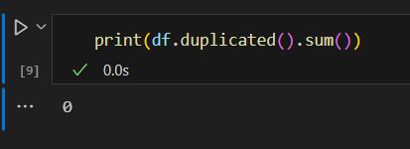

6.Check percentage of missing values

df.isnull().mean() * 100

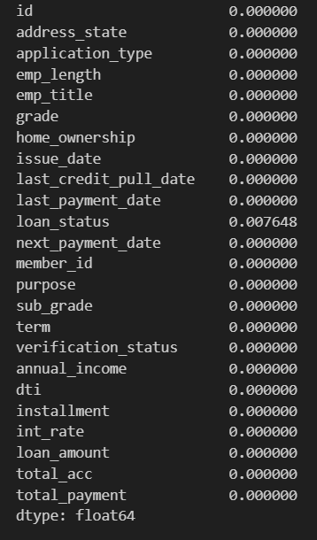

7.Strip the unknown value in the data:

df["emp_length"] = df["emp_length"].str.lstrip("<")

df["emp_length"] = df["emp_length"].str.lstrip("+")

df .head()

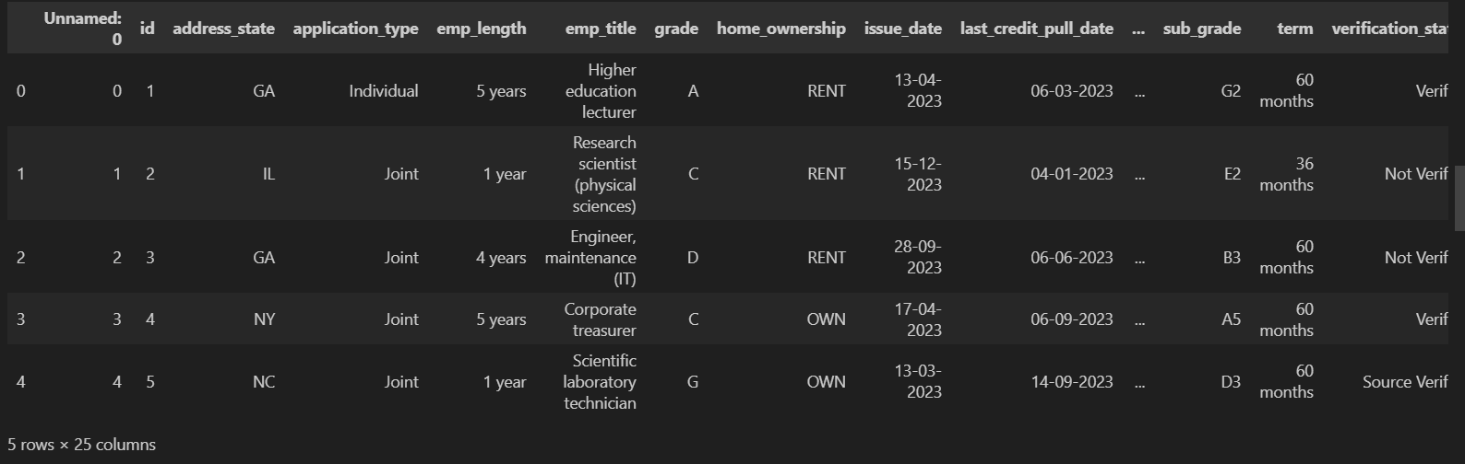

8.finding null value:

df.isnull().sum()

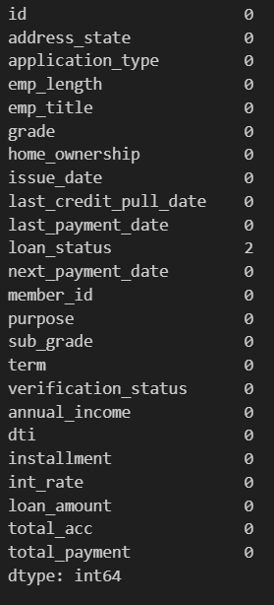

 9.Histogram & Boxplot for Numerical Features:

1.Histogram

import matplotlib.pyplot as plt

import seaborn as sns

df.hist(figsize=(10, 8), bins=30)

plt.show()

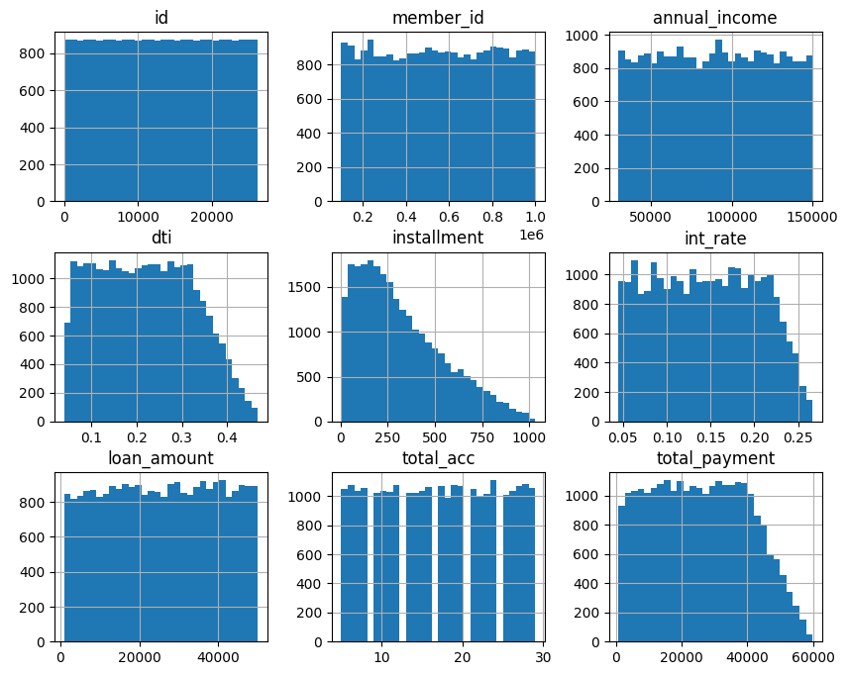

2.Boxplot

plt.figure(figsize=(8, 3))

sns.boxplot(data=df)

plt.xticks(rotation=90)

plt.show()

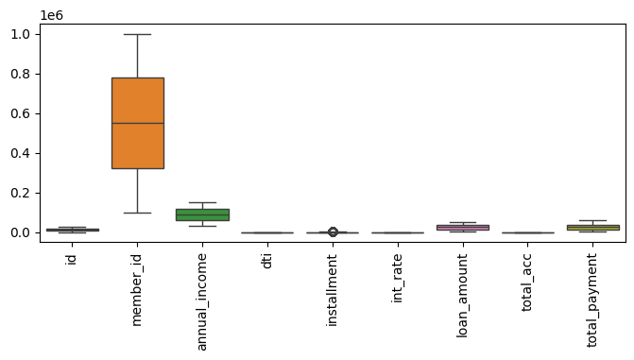

10. Count plot for term:

plt.figure(figsize=(8, 5))

sns.countplot(x=df['term'])

plt.xticks(rotation=90)

plt**.**show()

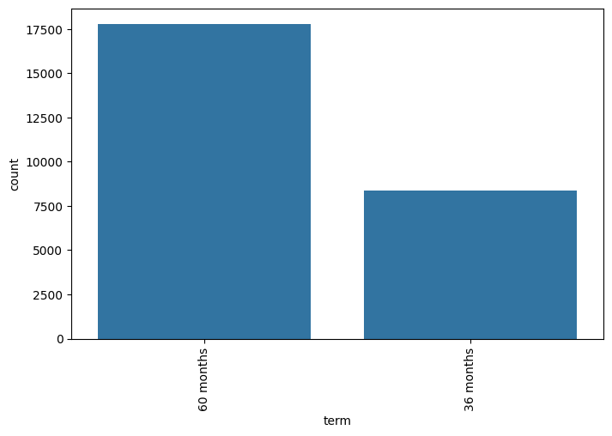

11. Save Cleaned Data:

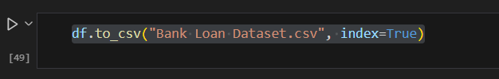

# SQL Database server connection and file import:

First install the SQL server management in your local pc and use your server name and Connect it.

# 

Create new database, add the name

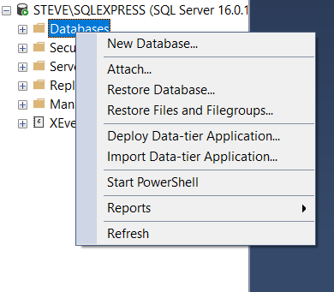 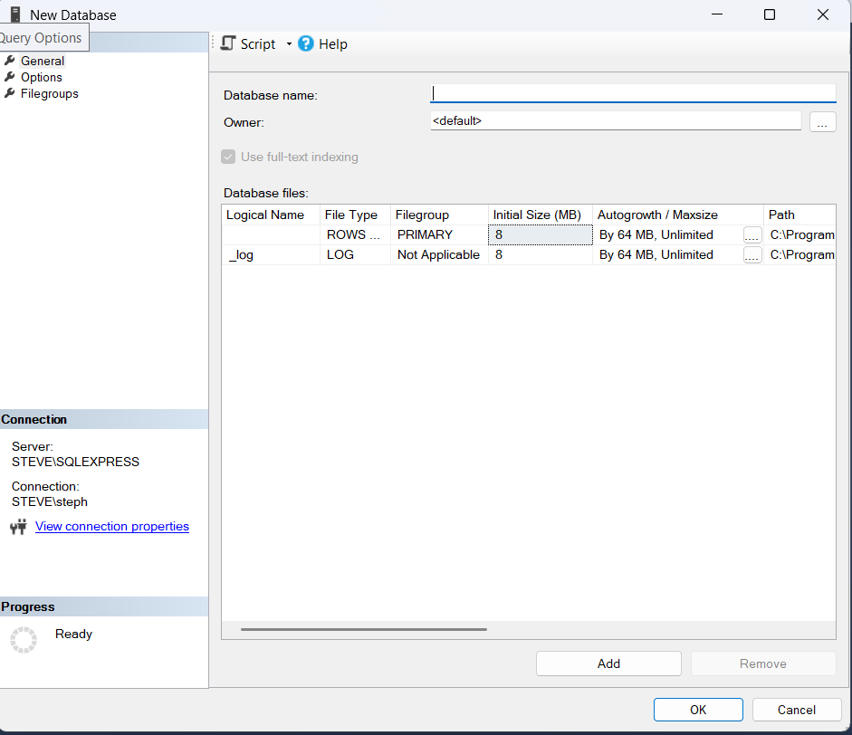

Import you flat file of csv only

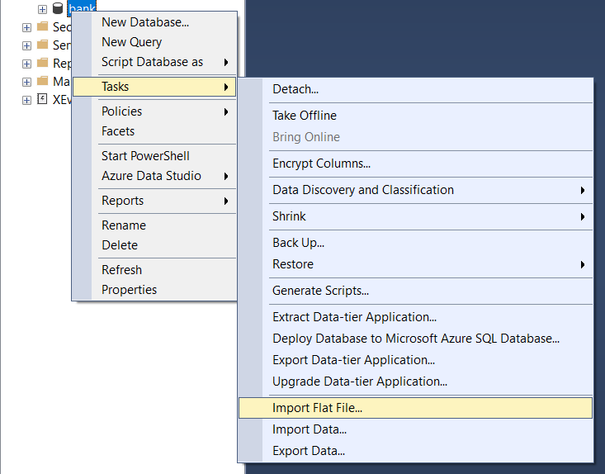

And Browse your file , click next

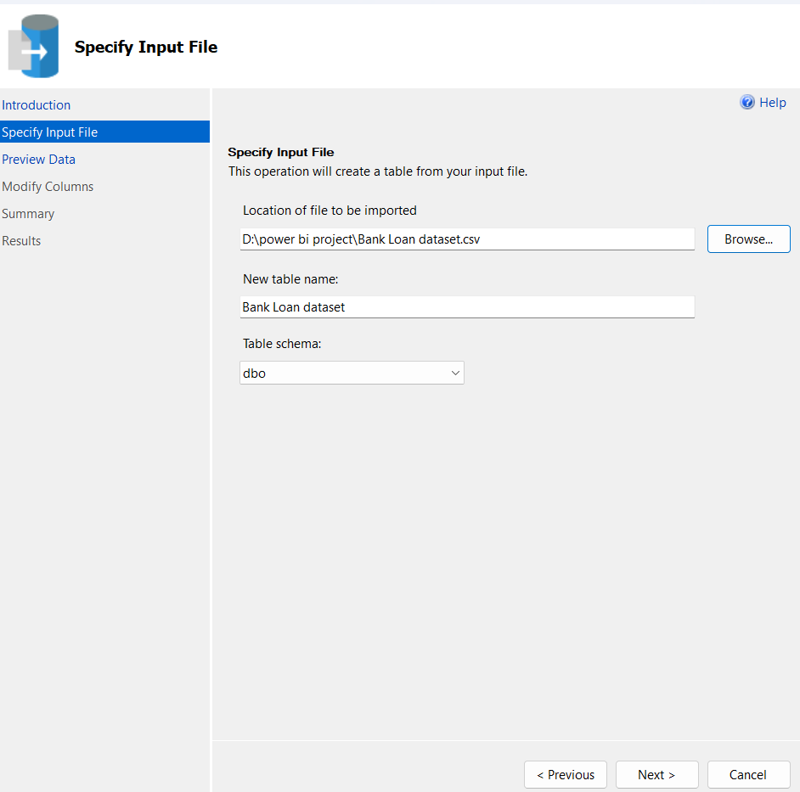

Modify the data types and primary key, click next and finish it.

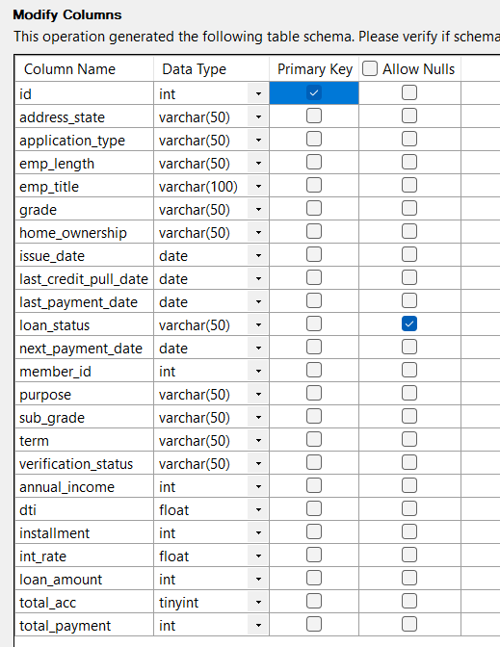 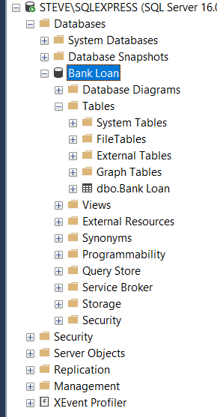

If any error appear now you need to change the datatype in different way.

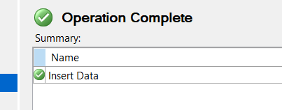

Then calculate the measures.

**BANK LOAN REPORT SQL QUERY DOCUMENT**

**BANK LOAN REPORT | SUMMARY:**

**KPI’s:**

**Total Loan Applications:**

SELECT COUNT(id) AS Total_Applications FROM bank loan



**MTD Loan Applications:**

SELECT COUNT(id) AS MTD_Total_Applications FROM bank loan

WHERE MONTH(issue_date) = 12



**PMTD Loan Applications:**

SELECT COUNT(id) AS PMTD_Total_Applications FROM bank loan

WHERE MONTH(issue_date) = 11



**Total Funded Amount:**

SELECT SUM(loan_amount) AS Total_Funded_Amount FROM bank loan



**MTD Total Funded Amount:**

SELECT SUM(loan_amount) AS MTD_Total_Funded_Amount FROM bank loan

WHERE MONTH(issue_date) = 12



**PMTD Total Funded Amount:**

SELECT SUM(loan_amount) AS PMTD_Total_Funded_Amount FROM bank loan

WHERE MONTH(issue_date) = 11



**Total Amount Received**

SELECT SUM(total_payment) AS Total_Amount_Received FROM bank loan



**MTD Total Amount Received**

SELECT SUM(total_payment) AS MTD_Total_Amount_Received FROM bank loan

WHERE MONTH(issue_date) = 12



**PMTD Total Amount Received**

SELECT SUM(total_payment) AS PMTD_Total_Amount_Received FROM bank loan

WHERE MONTH(issue_date) = 11



**Average Interest Rate**

SELECT AVG(int_rate)*100 AS Avg_Int_Rate FROM bank loan



**MTD Average Interest:**

SELECT AVG(int_rate)*100 AS MTD_Avg_Int_Rate FROM bank loan

WHERE MONTH(issue_date) = 12



**PMTD Average Interest:**

SELECT AVG(int_rate)*100 AS PMTD_Avg_Int_Rate FROM bank_loan_data

WHERE MONTH(issue_date) = 11



**Avg DTI:**

SELECT AVG(dti)*100 AS Avg_DTI FROM bank_loan_data



**MTD Avg DTI**

SELECT AVG(dti)*100 AS MTD_Avg_DTI FROM bank_loan_data

WHERE MONTH(issue_date) = 12



**PMTD Avg DTI**

SELECT AVG(dti)*100 AS PMTD_Avg_DTI FROM bank_loan_data

WHERE MONTH(issue_date) = 11



**GOOD LOAN ISSUED**

**Good Loan Percentage**

SELECT

(COUNT(CASE WHEN loan_status = 'Fully Paid' OR loan_status = 'Current' THEN id END) * 100.0)

/

COUNT(id) AS Good_Loan_Percentage

FROM bank_loan_data



**Good Loan Applications**

SELECT COUNT(id) AS Good_Loan_Applications FROM bank_loan_data

WHERE loan_status = 'Fully Paid' OR loan_status = 'Current'



**Good Loan Funded Amount**

SELECT SUM(loan_amount) AS Good_Loan_Funded_amount FROM bank_loan_data

WHERE loan_status = 'Fully Paid' OR loan_status = 'Current'



**Good Loan Amount Received**

SELECT SUM(total_payment) AS Good_Loan_amount_received FROM bank_loan_data

WHERE loan_status = 'Fully Paid' OR loan_status = 'Current'



**BAD LOAN ISSUED**

**Bad Loan Percentage**

SELECT

(COUNT(CASE WHEN loan_status = 'Charged Off' or loan_status = 'late' THEN id END) * 100.0) /

COUNT(id) AS Bad_Loan_Percentage

FROM bank_loan_data



**Bad Loan Applications**

SELECT COUNT(id) AS Bad_Loan_Applications FROM bank_loan_data

WHERE loan_status = 'Charged Off' or loan_status = 'late'



**Bad Loan Funded Amount**

SELECT SUM(loan_amount) AS Bad_Loan_Funded_amount FROM bank_loan_data

WHERE loan_status = 'Charged Off' or loan_status = 'late'



**Bad Loan Amount Received**

SELECT SUM(total_payment) AS Bad_Loan_amount_received FROM bank_loan_data

WHERE loan_status = 'Charged Off' or loan_status = 'late'



**LOAN STATUS**

SELECT

loan_status,

COUNT(id) AS LoanCount,

SUM(total_payment) AS Total_Amount_Received,

SUM(loan_amount) AS Total_Funded_Amount,

AVG(int_rate ) AS Interest_Rate,

AVG(dti) AS DTI

FROM

bank_loan_data

GROUP BY

loan_status

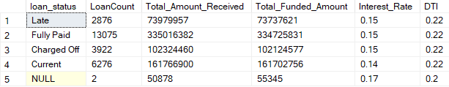

SELECT

loan_status,

SUM(total_payment) AS MTD_Total_Amount_Received,

SUM(loan_amount) AS MTD_Total_Funded_Amount

FROM bank_loan_data

WHERE MONTH(issue_date) = 12

GROUP BY loan_status

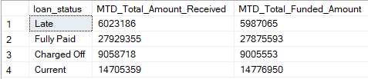

**BANK LOAN REPORT | OVERVIEW**

**MONTH**

SELECT

MONTH(issue_date) AS Month_Munber,

DATENAME(MONTH, issue_date) AS Month_name,

COUNT(id) AS Total_Loan_Applications,

SUM(loan_amount) AS Total_Funded_Amount,

SUM(total_payment) AS Total_Amount_Received

FROM bank_loan_data

GROUP BY MONTH(issue_date), DATENAME(MONTH, issue_date)

ORDER BY MONTH(issue_date)

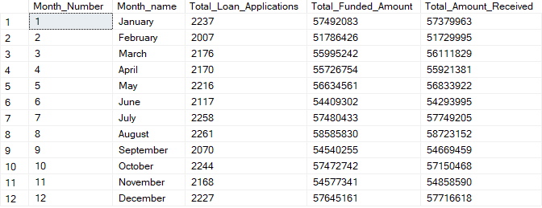

**STATE**

SELECT

address_state AS State,

COUNT(id) AS Total_Loan_Applications,

SUM(loan_amount) AS Total_Funded_Amount,

SUM(total_payment) AS Total_Amount_Received

FROM bank_loan_data

GROUP BY address_state

ORDER BY address_state

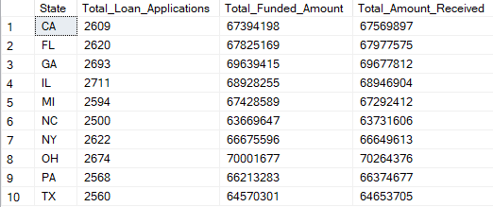

**TERM**

SELECT

term AS Term,

COUNT(id) AS Total_Loan_Applications,

SUM(loan_amount) AS Total_Funded_Amount,

SUM(total_payment) AS Total_Amount_Received

FROM bank_loan_data

GROUP BY term

ORDER BY term

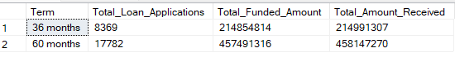

**EMPLOYEE LENGTH**

SELECT

emp_length AS Employee_Length,

COUNT(id) AS Total_Loan_Applications,

SUM(loan_amount) AS Total_Funded_Amount,

SUM(total_payment) AS Total_Amount_Received

FROM bank_loan_data

GROUP BY emp_length

ORDER BY emp_length

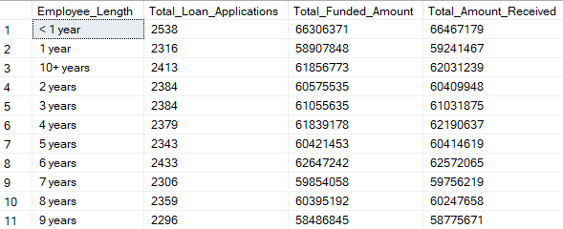

**PURPOSE**

SELECT

purpose AS PURPOSE,

COUNT(id) AS Total_Loan_Applications,

SUM(loan_amount) AS Total_Funded_Amount,

SUM(total_payment) AS Total_Amount_Received

FROM bank_loan_data

GROUP BY purpose

ORDER BY purpose

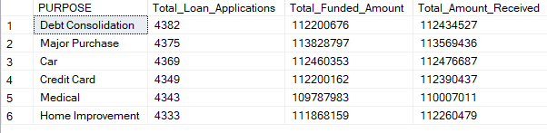

**HOME OWNERSHIP**

SELECT

home_ownership AS Home_Ownership,

COUNT(id) AS Total_Loan_Applications,

SUM(loan_amount) AS Total_Funded_Amount,

SUM(total_payment) AS Total_Amount_Received

FROM bank_loan_data

GROUP BY home_ownership

ORDER BY home_ownership

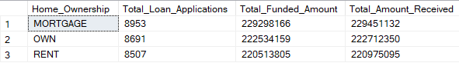

*SELECT*

*purpose AS PURPOSE,*

*COUNT(id) AS Total_Loan_Applications,*

*SUM(loan_amount) AS Total_Funded_Amount,*

*SUM(total_payment) AS Total_Amount_Received*

*FROM bank_loan_data*

*WHERE grade = 'A'*

*GROUP BY purpose*

*ORDER BY purpose*

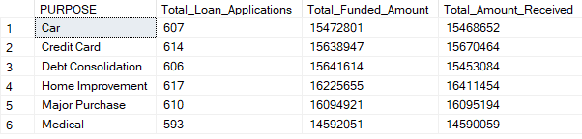

**POWER BI POWER QUERY FOR NEW MEASURE**

**First create new table in table view:**

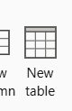

Create new column of DATE:



Create new column of MONTH:



The table view like

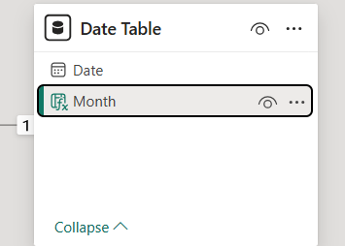

Then need to create a relationship with main table dataset:

Click “date” on the date table and drage to release in our bank loan table of “issue_date”

And our view like this

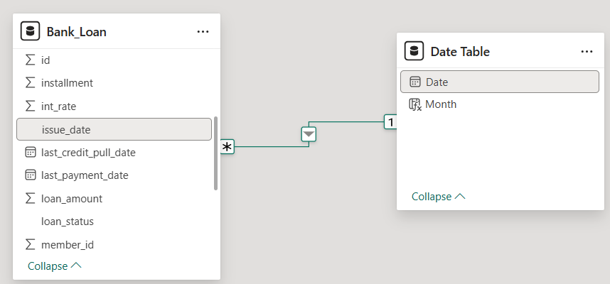

And then create the Dashbord in the report view

Create Dashboard:

PAGE 1:(Summary)

Use card to build the vuzuale: 

1.Create Total_Loan_Application use new measure:



2.Create Month_To_Date_Loan_Application :



3.Previous_Month_To_Date_Loan_Application:



4.Month_On_Month_Loan_Application:



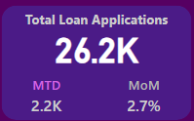

1.Create Total_Funded_Amount



2. Month_To_Date_Funded_Amount



3. Previous_Month_To_Date_Funded_Amount



4. Month_On_Month_Funded_Amount



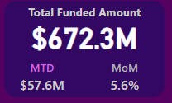

1.Create Total_Amount_Received:



2. Month_To_Date_Amount_Received:



3. Previous_Month_To_Date_Amount_Received:



4. Month_On_Month_Amount_Received:



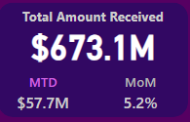

1.Create Average Intreast Rate:



2. Month_To_Date_Average Intreast Rate:



3. Previous_Month_To_Date_Average Intreast Rate:



4. Month_On_Month_Average Intreast Rate:



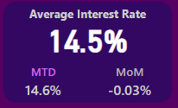

1.Create Average Dept To Income:



2. Month_To_Date_Average Dept To Income:



3. Previous_Month_To_Date_Average Dept To Income:



4. Month_On_Month_Average Dept To Income:



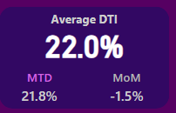

GOOD LOAN AND BAD LOAN USE DONUT CHART and new card:

First group the good loan and bad loan of use loan_status

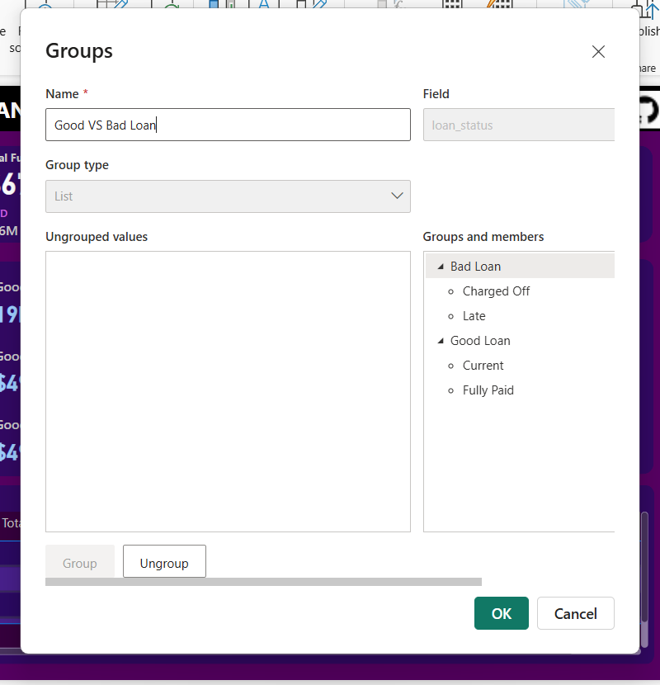

Good Loan vizuale: 

Use Donut chart,

And the 50% Percentage is ,



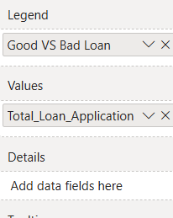 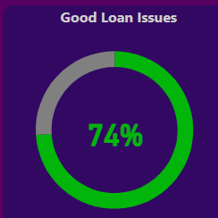

1.create Good_Loan_Application



2. Good_Loan_Funded_Amount



3. Good_Loan_Amount_Received

Use new card to vizuale 

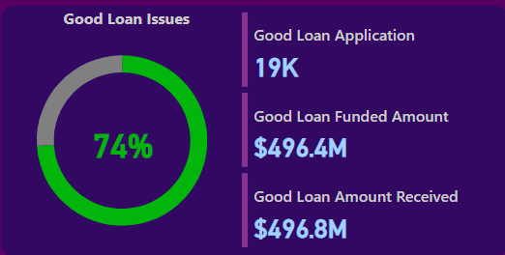

Bad Loan vizuale: 

Use donut chart,

And the 50% Percentage is ,



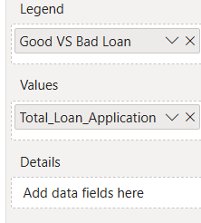 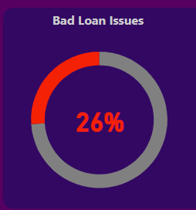

1.Bad_Loan_Application:



2. Bad_Loan_Funded_Amount:



3. Bad_Loan_Amount_Received:



Use new card to vizuale 

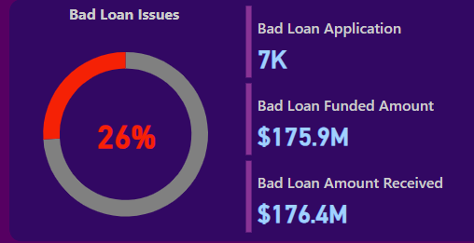

Create table vizuale for Loan Status:

Use table visualization 

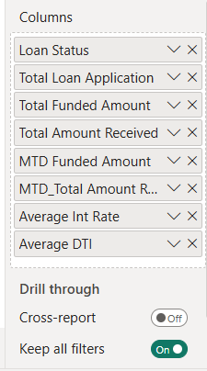 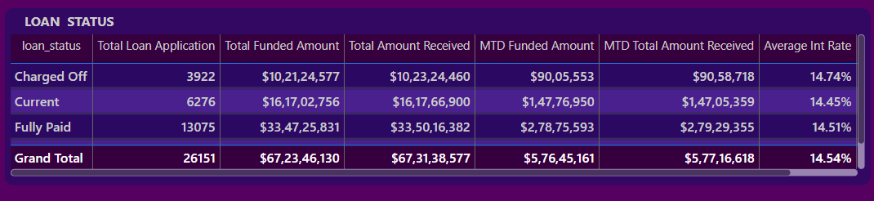

Then control slide: 

Use slicer vizualizasion, to “State” , “Grade” ,”Purpose”

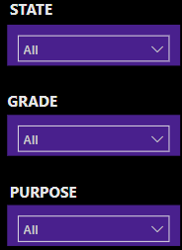 And it bookmarked in the action to hid eand show 

OUR FIRST PAGE :

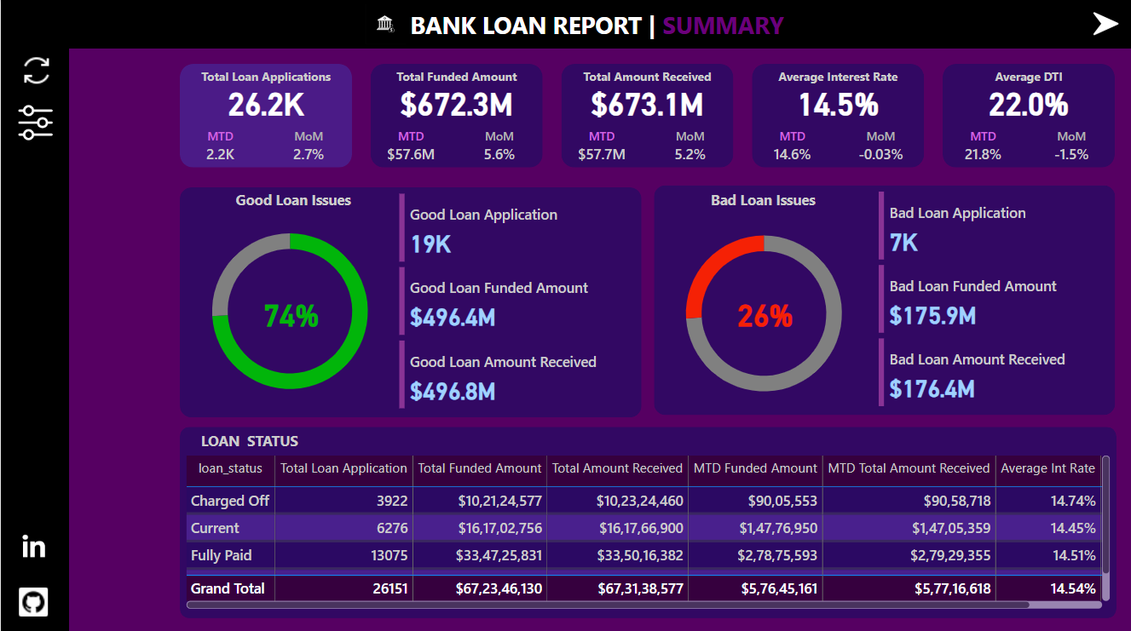

PAGE 2 (Overview)

Second need duplicate it ,

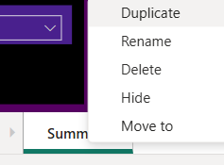

Need the Total loan Application , Total Funded Amount ,Total Amount Received ,Average Intrest Rate ,

Average DTI in privious Report Page

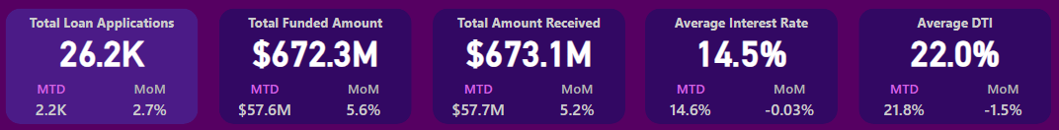

1.First need to Create the “Month” And “Month Number” in Date Table





Final table is,

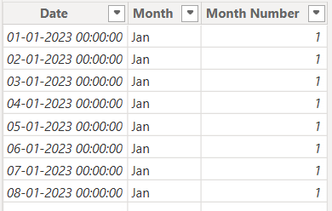

2.Secondly Create “Select Measure”

Go to Modeling -> New Parameter -> Fields

Neme -> Select Measure

Fields -> select , Total Amount Received , Total Funded Amount , Total Loan Amount

Click Create

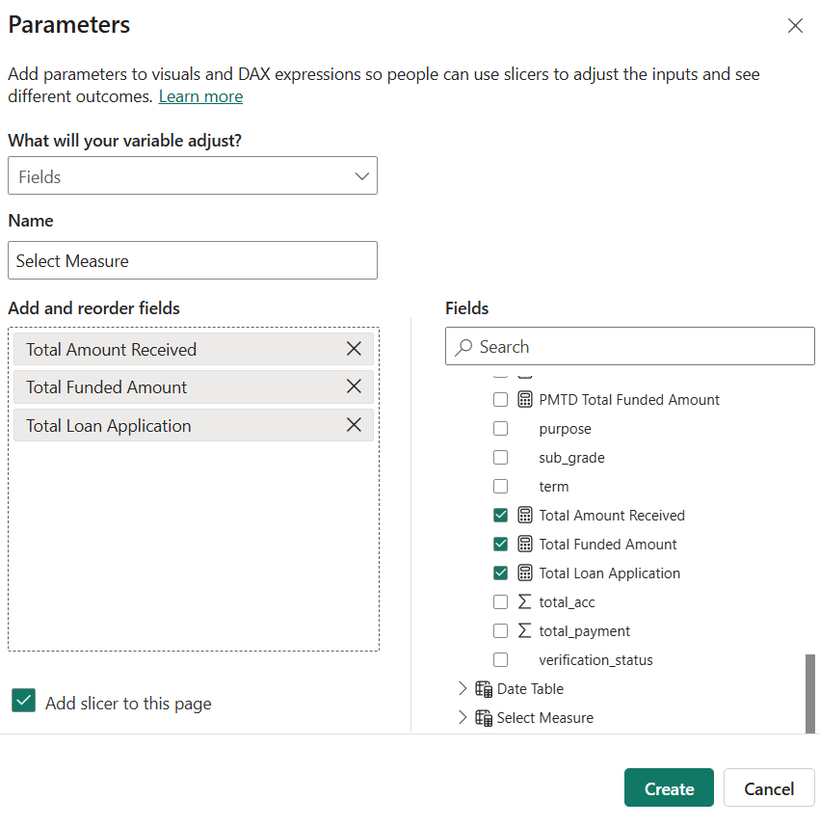

The automaticaly create one slicer graph and formt it

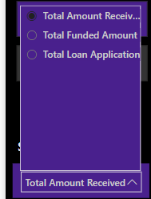

1.Create Graph “Select Measure” by “Month” using Area Chart

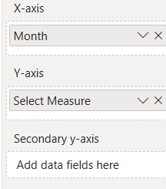 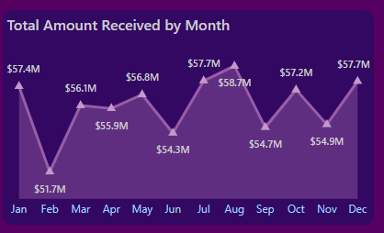

2.Then Create “Select Measure” by “State” using Shape map

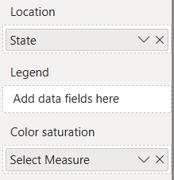 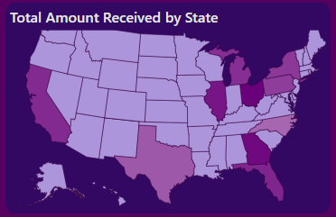

3.And Create “Select Measure” by “Term” using Donut Chart

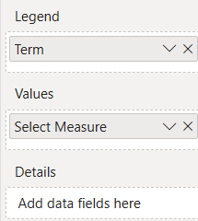 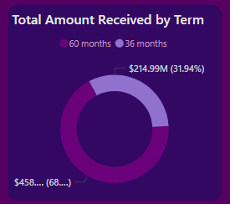

4. And Create “Select Measure” by “Employee Length” using Stacked Bar Chart

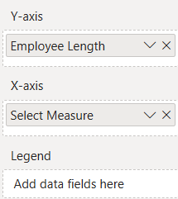 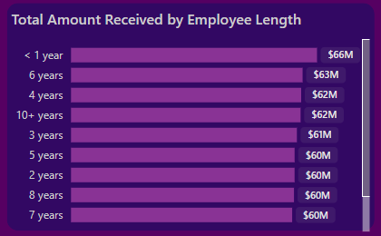

5. And Create “Select Measure” by “Purpose” using Stacked Bar Chart

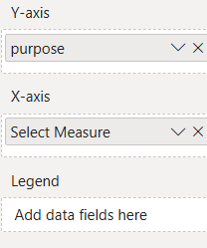 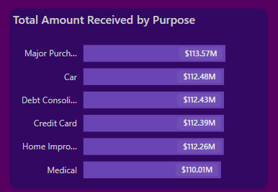

6. Finally Create “Select Measure” by “Home Ownership” using Treemap

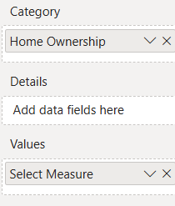 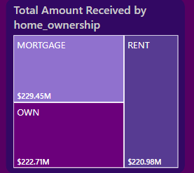

7. Then Add two new Slicer in the navigater side file use “Select Measure” And “Good VS Bad Loan”

Delete the “Purpose” Slicer

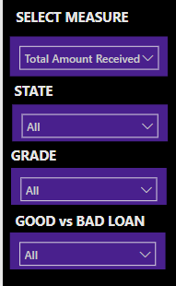 added in the bookmark action

OUR SECOND PAGE:

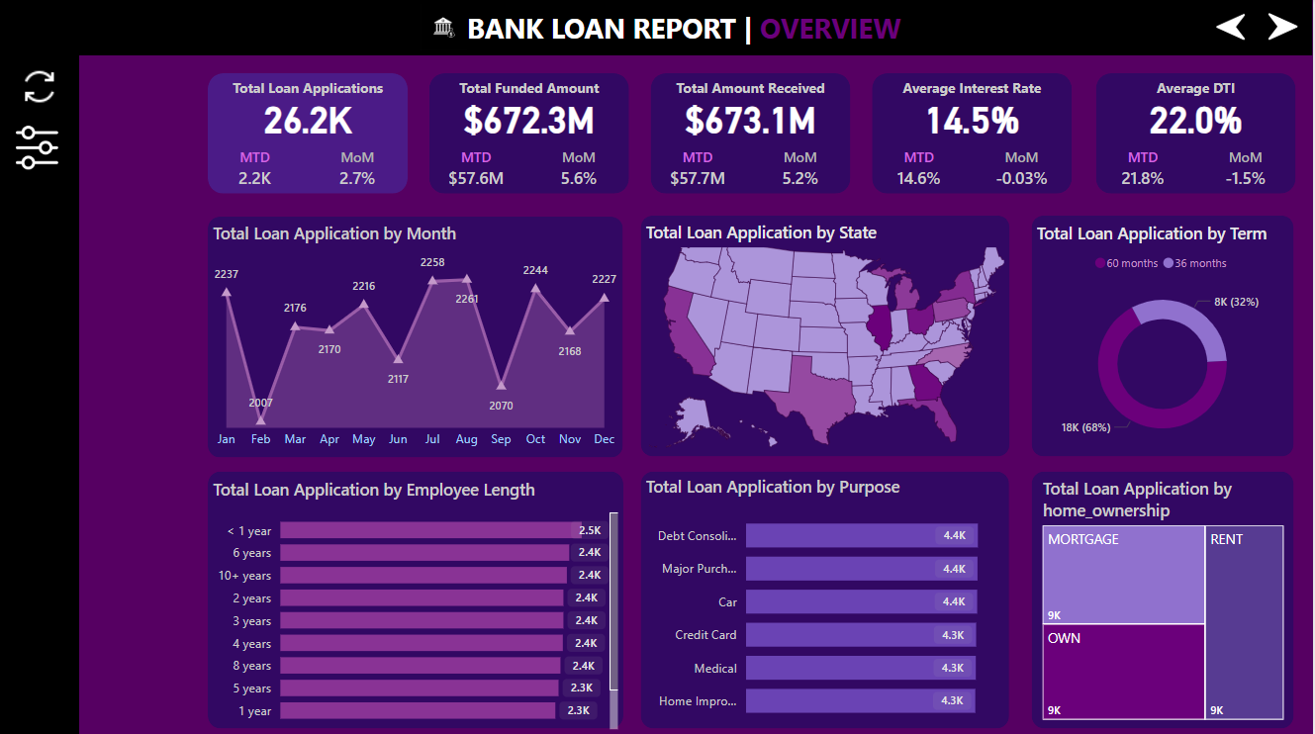

PAGE 3: (Details)

Third need duplicate it ,



Need the Total loan Application , Total Funded Amount ,Total Amount Received ,Average Intrest Rate ,

Average DTI in privious Report Page

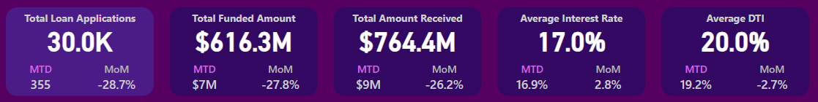

This Page Show Details of the loan in the dataset to preview it,

Use “Table” vizualizasion and add the measurment in the table,

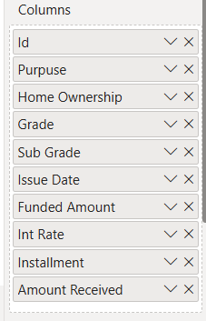 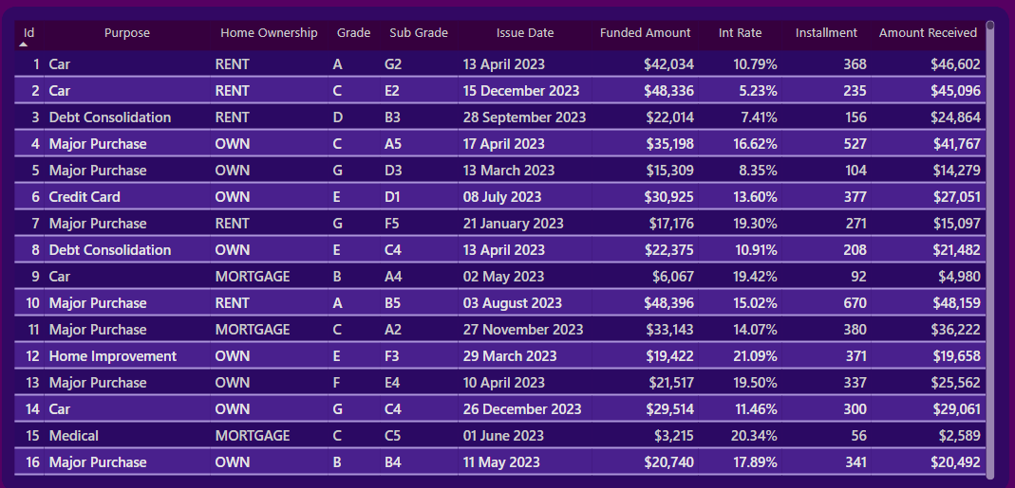

Delete the “select measure” in the navication side,

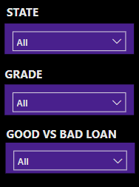

OUR FINAL PAGE :

